
Delhi Technical Campus Greater Noida
Assignment 3

Instructions:
- All questions are compulsory to attempt.
- Assignment must be submitted in handwritten manner in separate notebook.
- Submit the assignment on or before (Mentioned date).
- Marks will be deducted and analysed as per the submission dates. At late submission marks will be deducted.

Subject: Design and Analysis of Algorithm Subject Code: CIC-311
Class: B.Tech CSE 5th Faculty Name: Ms. Anshul
Date of Issue: 25/10/2023 Date of Submission: 13/11/2023

1 | Apply dynamic programming to find optimal subsequence for multiplication. A1[5,x,4], A2[4,x,3], A3[3,x,2] and A4[2,x,9]. Also find the optimal paranthesization of matrices. | CO3 | L3
2 | Use Dynamic Programming to find the longest common subsequence of following two string <011010> and <10110>. | CO3 | L2
3 | Write the optimal binary search tree algorithm and explain it with the help of example. | CO3 | L2
4 | Consider following Knapsack problem in which there are three objects, with weights w={1,2,3} and values v={2,3,4}. The Knapsack capacity of Knapsack is 3. Calculate the maximum possible value of Knapsack using Dynamic programming. | CO3 | L4
5 | Apply Floyd Warshal algorithm for constructing shortest path.  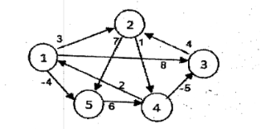 | CO3 | L3

